**Topic 11: Research Issues and Current Topics Healy and Lo**

Jumping the Gates: Using Beta-Overlay Strategies to Hedge Liquidity Constraints

 Note: “The Gates”

* Beta-blocker overlay
* Commonality
* Definability
* Hedging equation
* Tradability
* Unwind risk

1. **Describe the beta-hedging overlay strategy.**

* Drs. Andrew Lo and Alexander Healy propose a future overlay strategy designed to hedge out or control the common factor exposures of gated assets.
* The study demonstrates that by taking countervailing positions in stock, bond, currency, and commodity exposures, an investor can greatly reduce the systematic risks of their gated assets while still enjoying the benefits of manager-specific alpha.
* The researchers propose that such overlay strategies can also be used to reposition the betas of an investor’s entire portfolio, effectively rebalancing asset-class exposures without having to trade the less liquid underlying assets during periods of market dislocation.
* Gates are restrictions on investor withdrawals that are implemented when the total redemption requests for a hedge fund exceed a threshold value.
* Gates help slow the rate at which assets must be sold to meet investor redemption requests. The risk of loss from unwinding positions is known as unwind risk.
* Gates limit withdrawals in an attempt to limit potential losses from unwind risk.

**2. Identify the three criteria that, according to the authors, must be satisfied by a risk**

**factor to be considered an economic variable.**

* 1. Definability. Well defined and measurable.
  2. Commonality. It is related to a broad set of hedge funds
  3. Tradability. There exist liquid futures or forward contracts that capture economic effects.

**3. Discuss the conditions that must be met in order to implement a beta-hedging overlay strategy.**

* Investor believes that the expected returns to be hedged are temporarily negative
* Investor believes that the risk reduction from hedging the risk factors is worth the prices of forgoing the normally positive expected returns
* The investor already has significant exposure to the risk factors to be hedged
* Risk factors to be hedged are incidental to the expected return of the manager

**4. Outline the construction of a beta-hedging overlay program.**

* Determine the hedging equation (i.e., the risk factor model)

What are overlay strategies?

* Overlay strategies are investment strategies that use derivative investment vehicles to obtain, offset or substitute specific portfolio exposures, beyond those provided by the underlying portfolio assets. They allow pension fund sponsors to increase or reduce exposure in a fund, relative to its actual funded amount.
* The strategies generally involve a synthetic replication of an asset class, market or factor exposure, such as portable alpha, foreign exchange overlays, rebalancing, liability-driven investments, cash equitization, hedge fund replication, and completion overlay.
* The fair value of the overlay portfolio is often very small or even zero because it is generally funded and implemented by using derivatives. The overlay portfolio can be highly leveraged as a result of using derivatives.
* With an overlay, an investor decides to sell options on a security they own, generating premium income in the process. Along with accumulating income, an overlay strategy may have the secondary objective of acquiring more of an asset or closing out what is already owned.

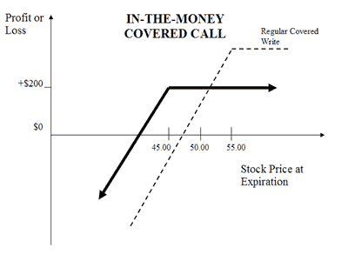

**5. Describe the relationship between the fit (i.e., R-squared) of the linear factor model and the risk reduction that can be achieved through a beta-blocker program.**

* Figures show that for a hedge fund with an R2 of 50%, a beta blocker will reduce the volatility by about 29%.
* The realized performance of the beta blocker may differ from the estimated performance.

**6. Summarize the empirical evidence of the beta-blocker program when applied to**

**Long/Short Equity funds. BETA BLOCKER**

We find that, on average, the beta blocker program

* reduces the volatility
* maximum draw downs
* autocorrelations
* increases the Sharpe ratios of the funds
* modest reduction in average monthly return.

**7. Describe the implications of daily hedging using the beta-blocker framework. Dynamic Hedging vs. Regular Beta hedging.**

* Higher returns in UP market periods
* Lower returns in DOWN market periods
* Less reduction in volatility across both up and down markets

Locking in Profits or Putting It All on Black? An Empirical Investigation into the Risk-Taking Behavior of Hedge Fund Managers Clare and Motson

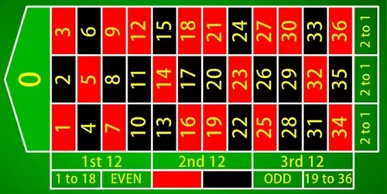

* Assessment period
* Risk adjustment ratio (RAR)
* Tournament behavior

**1. Understand the relationship between the fee structure and risk-taking behavior of hedge fund managers**

* Unnecessarily increase the SIZE of the fund to collect fees (Increase AUM)
* Unnecessarily engage in riskier investments to meet the High Water Mark

**2. Discuss the two important reasons why hedge fund incentive fees are a contentious issue.**

1. Fees are Too Large! Not justified. Hurts returns.

2) Free Call Option

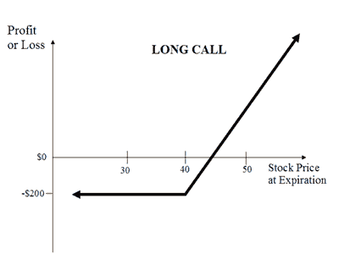

**3. Compare and contrast the fund manager’s risk choices under the following theoretical models of behavior:**

* Carpenter (2000) & Hodder and Jackwerth (2007)

Funds will increase risk as fund value declines

* Goetzmann Ingersoll and Ross (2003)

Funds will decrease risk as fund value declines

* Hodder and Jackwerth (2007)

Funds will employ either the increase or the decrease

* Panageas and Westerfield (2009)

They argue the infinite horizon of call options. So, manager won’t be too risky – because it will affect chances in the future of the next series of call options.

**4. Explain the concept of the moneyness of the incentive options for hedge funds.**

* Moneyness = NAV / HighWaterMark

**5. Discuss two explanations for the finding that the standard deviation of funds without-of-the-money incentive options and funds with in-the-money incentive options are statistically larger than the standard deviation of funds with at-the money incentive options.**

1. Hedge funds increase their risk when they are significantly below or above their high watermark as defined in expression

2) High Volatility Funds are more likely to end up ITM or OTM

**6. Discuss the empirical findings of this paper in relationship to the risk-taking decisions of hedge fund managers and their realized relative performance:**

* Funds which have made money tend to lock it in
* Funds which are down money will take punts

**7. Discuss the empirical findings of this paper in relationship to the risk-taking decisions of hedge fund managers and the value of their incentive option:**

* Funds that are OTM or ITM will decrease risk (lock in profits)
* Funds that are ATM will increase risk

**8. Discuss the relationship between fund size, age, survival and risk-taking.**

* Clare and Motson actually show that there is NO SIGNIFICANCE

Warning: Physics Envy May be Hazardous to Your Health Stat arb strategy

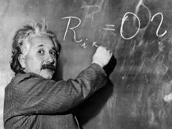

* Fully reducible uncertainty
* Irreducible uncertainty
* Mean-reversion
* Partially reducible uncertainty
* Risk vs. Uncertainty
* Uncertainty continuum

**1.Explain the difference between risk and uncertainty.**

* Risk is measurable while uncertainty is not measurable.

**2. Understand and explain the 5 levels of uncertainty:**

* Level 1: Complete certainty
* Level 2: Risk without uncertainty
* Level 3: Fully reducible uncertainty
* Level 4: Partially reducible uncertainty
* Level 5: Irreducible uncertainty

**3. Discuss how the concept of model uncertainty fits into the “taxonomy of**

**uncertainty.”**

* Level 1: Complete certainty: Not applicable
* Level 2: Risk without uncertainty: Derive estimators and employ statistical inference
* Level 3: Fully reducible uncertainty: Evaluate the strategy through back testing
* Level 4: Partially reducible uncertainty: Consider data biases
* Level 5: Irreducible uncertainty: Check data for errors and outliers

**4. Describe the main characteristics of the statistical arbitrage strategy that attempts**

**to benefit from mean-reversion in stock returns when there is risk without uncertainty:**

* Level 1: Complete certainty
* Level 2: Risk without uncertainty

Long and shorts making the strategy market neutral

* Level 3: Fully reducible uncertainty

Lo and Mueller show extremely large returns at the beginning, and then declining returns as time progresses.

* Level 4: Partially reducible uncertainty

The effect of the trading strategy on prices must be considered.

* Level 5: Irreducible uncertainty

The StatArb strategy cannot be specifically modeled to account for Level 5 Uncertainty.

Example was the SEC halting short selling.

**5. Explain why a statistical arbitrage strategy that attempts to take advantage of mean-reversion in stock returns performs better when applied to small cap stocks. Understand the role of a liquidity provider in this context.**

* Works better with less Liquid Equities
* Small cap stocks are less liquid and less efficient than large cap stocks.

**6. Understand why certain rare events may be predictable while some rare events may remain unpredictable (e.g., the so-called black swans).**



**7. Describe the role of incentives and moral hazard in risk management.**

* Someone will drive more recklessly when they have insurance
* Principal-agent problem. Agents and principals have divergent interests.

**8. Describe the elements of the uncertainty checklist for levels 1-5 in the following**

**Context: empirical analysis, portfolio construction, trading and implementation, risk management.**

* Empirical analysis

Level 1: N/A

Level 2: Econometric methods

Level 3: Backtesting

Level 4: Data Biases

Level 5: Errors and outliers

* Portfolio Construction

Level 1: Mathematics of the model

Level 2: Mean-variance optimization using known parameters

Level 3: Mean-variance optimization using estimates

Level 4: Non-stationary or time-varying estimates for mean and variance

Level 5: Unpredictable events like trading halts and short-sale restrictions. SEC.

* Trading and Implementation ORDER FILLS

Level 1: Direct Trading Costs

Level 2: Probability that an order will be filled

Level 3: Probability that an order will be filled using estimates

Level 4: Indirect Costs and Possibility of Technology Failure

Level 5: Unpredictable events like Flash Crash

* Risk Management

Level 1: No risk to manage

Level 2: Probability theory and distributions used to model risk

Level 3: Statistical methods

Level 4: Non-stationarity and regime switching models

Level 5: Extreme tail events that cannot be modeled. Black Swans.

Non-Normality, Facts and Fallacies

Author Esch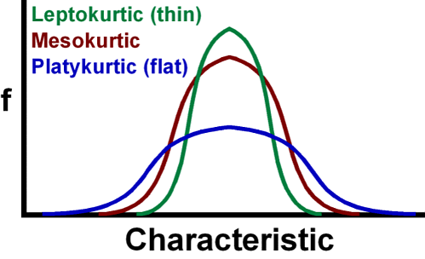

**1. Discuss the advantages, criticisms and defenses of mean-variance optimization for portfolio management in the context of normal and non-normal return distributions.**

* (MV) Mean Variance portfolio assumes stock returns are jointly normally distributed.
* Advantage: it can incorporate nonlinear constraints when normality is a good approximation
* Advantage: it is a simpler model and error estimation error is less likely

**2. Discuss the potential advantages and disadvantages of fitting highly complex and less complex models to dataset histories of varying lengths.**

* Complex models can detect and use more information but might overfitting
* Simpler model is less likely to face Over fitting

**3. Explain potential disadvantages and challenges of estimating higher moments or fitting higher moment models using limited data with or without normality.**

* Estimates often become unstable
* The challenge becomes estimating higher moments without increasing the estimation error in the lower moments

**4. Explain the potential challenges that outliers present in affecting the estimates of higher moments of return distributions.**

* Outliers can significantly affect the estimation of a distribution’s parameters and often introduce large sampling errors.

**5. Analyze the effects of varying skewness while keeping the mean and the variance**

**fixed.**

The distribution shifts to the LEFT

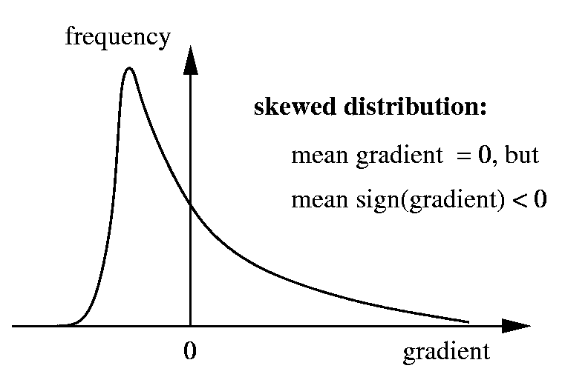

* More mass falls below the median. When things are stable --- this is BAD.

**6. Analyze the effects of varying kurtosis while keeping the mean, the variance and**

**the skewness fixed.**

* Trade off of concentration around mean against fatter tails
* Increased Kurtosis increases chance of average outcome and increases the chance of tail event (heavier tails).

